Customer Questionnaire for Lead and Copper Testing of Drinking Water

The |  | Water System is required to do Lead and Copper testing at least every
three years at different locations within our distribution system. In order to compile a database of the materials used in our customer’s service lines and plumbing required by our sampling plan, please take a few minutes to complete this questionnaire and return to:

We thank you for your cooperation in helping us with this to continue to serve clean and safe drinking water to our customers.

Contact Information
Name of Person filling out this questionnaire:
Phone Number should we have questions:

Property Information
Address (use separate sheet for each property):
Type: | Single Family |  |  | Multi-Family |  | Commercial | Industrial
Year Built: |  | Before 1982 | After 1982

Water Service Components

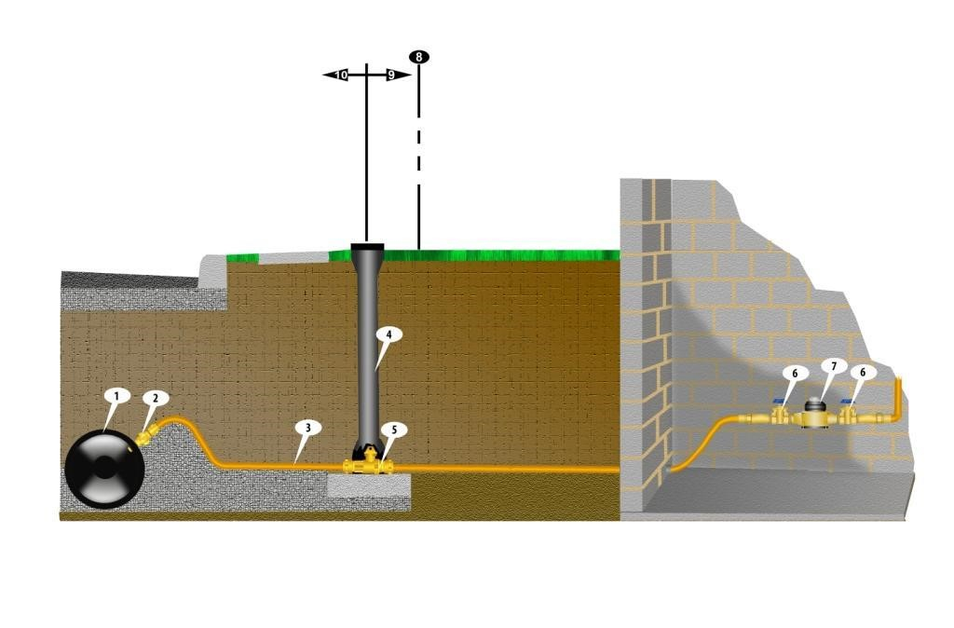

1. Water main
2. Corporation stop (service is tapped to main)
3. Service line
4. Curb box (allows access to curb-stop valve)
5. Curb-stop valve (usually located on/near property line)
6. House shut-off valve before meter (located in basement)
7. Water meter
6. Optional valve to keep household plumbing from draining, after meter

Materials List
- What material is your service line (3) made of? (Check all that apply)
 | Lead |  | Copper |  |  | Galvanized steel |  | P.E. (polyethylene) |  | Unknown
- When was the service line going into your house or business installed?
 | Before 1982 |  |  | After 1982
- What material are the pipes in your house or business made of? (Check all that apply)
 | Lead |  | Copper |  |  | Galvanized | PVC |  | PEX
- How old are the pipes inside your house?
 | Installed before 1982 |  |  |  | Installed after 1982
- Do you have a water softener or a whole home water purification system or any other treatment device installed in your house or business?
 | Yes | No
- If you answered yes to question 5, do you have an untreated, cold water kitchen or bathroom faucet?
 | Yes | No
- If your home or business meets the criteria for lead and copper sampling, would you be willing to participate in this testing? During testing, a Water Supply Employee would bring an empty bottle to your house, provide you with documentation and instructions on collecting the sample, and pick it up the next morning. Sampling frequency is typically every three years.
 | Yes | No

Thank you for participating in this survey; the data collected will allow us to provide accurate sampling and test results to determine the level of lead and copper found in our homes and businesses and to make appropriate treatment changes to lower or eliminate lead or copper leaching from service lines, plumbing, and fixtures in our customers’ homes and businesses.

